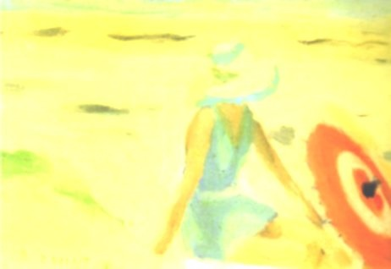
#2016AWW Bingo Card One
A book with a mystery | A book by someone under thirty | A book that’s more than 10 years old
A book by an Indigenous author | FREE SQUARE | A bestseller
A book set in the outback | A short story collection | A book published this year

