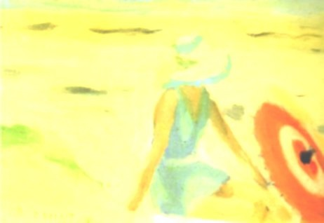
#2016AWW Bingo Card Two
A book set in your favourite town or city | A forgotten classic | A book you heard about online
A funny book | FREE SQUARE | A book by someone of a different ethnicity to you
The first book by a favourite author | A book with poems | A book of non-fiction

